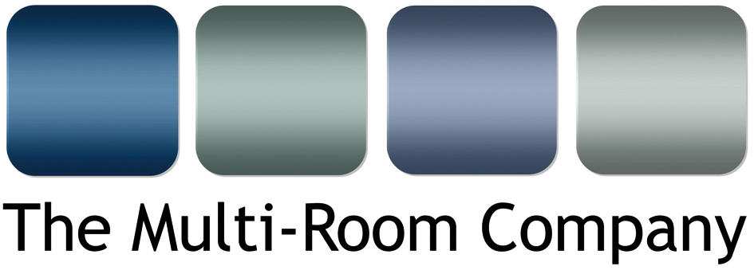

Unit 5, Eastside Industrial Estate
Mead Road, Cheltenham
Gloucestershire
GL53 7EF
T. +44 (0)1242 511133
www.multi-room.com
7 April 2015

NEWS RELEASE

The Multi-Room Company appointed as exclusive UK distributer for Cabasse loudspeakers

The Multi-Room Company Ltd. has been appointed by Cabasse, France’s most innovative loudspeaker manufacturer, as the exclusive UK distributor for its entire range of custom installation, home cinema and hi-fi loudspeakers, plus its growing range of streaming products. Effective immediately, this new arrangement will provide an enhanced customer experience for Cabasse’s existing customers and open up new business opportunities for The Multi-Room Company and its client base.

Based in Brittany, Cabasse has been manufacturing loudspeakers since 1950, when Georges Cabasse, a descendent of five generations of Luthiers who made their first violin in 1740, produced his first loudspeaker. Since then the company has been at the forefront of technical and acoustic innovation, perfecting the design and production of point source coaxial drive units and digital signal processing.

The Cabasse loudspeaker range addresses customer requirements with a unique technology and three distinctive design approaches: traditional boxes, lifestyle and custom install. Common to all variants, regardless of aesthetics, is the company’s coaxial driver technology, which was developed for the reproduction of natural timbres that are neutral and transparent with a wide, stable and full soundstage. The large sweet spot exhibited by the coaxial driver makes them ideal for custom installation and home cinema use, where multiple listening positions are common, but also high-end two channel systems as epitomised by the iconic flagship product, La Sphère.

…/

Also being made available via The Multi-Room Company is the recently announced Stream range of wireless music streamers, which bring high resolution streaming capabilities to the customer in a variety of form factors: stand alone powered speakers, a streamer add-on for existing hi-fi systems, a 2.1 sub sat for use with a TV and a self contained streamer/amplifier. Controlled via the Cabasse StreamCONTROL app (iOS and Android), the Stream range offers whole house connectivity, Spotify, Deezer, DLNA compatibility for streaming from a NAS drive, NFC Bluetooth, vTuner internet radio and synchronised party-mode playback. The Stream range also answers the installers perennial question of traditionally low margins on streaming products by offering the same margin enjoyed across other electronics.

Mike Bonnette, product director for The Multi-Room Company, is pleased to welcome Cabasse into the company’s portfolio, “The addition of this incredible range of products provides our customers with a solution for all eventualities, whether they are specifying a compact 5.1 system, a full-scale installed home cinema, a high-end two channel hi-fi, or want to stream wirelessly throughout the house.” He continues, “The size of the range is topped only by its quality; everything from the entry level bookshelf speaker, right up to the flagship model, via the in-wall products, conforms to Cabasse’s stringent music reproduction standards. We feel sure our customers are going to be thrilled to be able to specify these amazing speakers and we’re very excited by the new business opportunities it presents to us.”

Ends.
No embargo
© Red Sheep Ltd. 7 April 2015

Media contact: Phil Hansen 07813 893525
phil@redsheep.co.uk

Information for Editors

About The Multi-Room Company
Founded in 2001, The Multi-Room Company is a trade distributor of custom installation and hi-fi products. A ‘one stop shop’ for the trade (AV professionals, Custom Installers and Electricians), the company is the sole UK distributor of several highly respected brands and sub-distributors for other leading electronics manufacturers, including: Atlantic Technology, Cabasse, Centralite, Garvan, Key Digital, Leviton, Parasound, Russound, Sanus and Yamaha.

