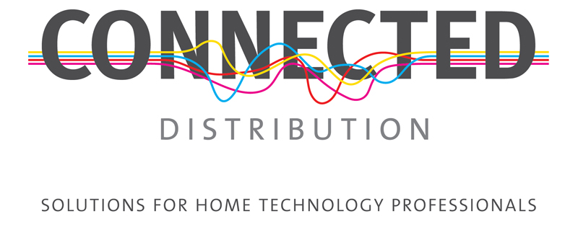
Unit 5, Eastside Industrial Estate
Mead Road, Cheltenham
Gloucestershire
GL53 7DT
T. +44 (0)1242 511133
www.connecteddistribution.com
1 April 2016

PRESS RELEASE
For immediate attention

Home theatre and streaming from Cabasse with the Stream BASE

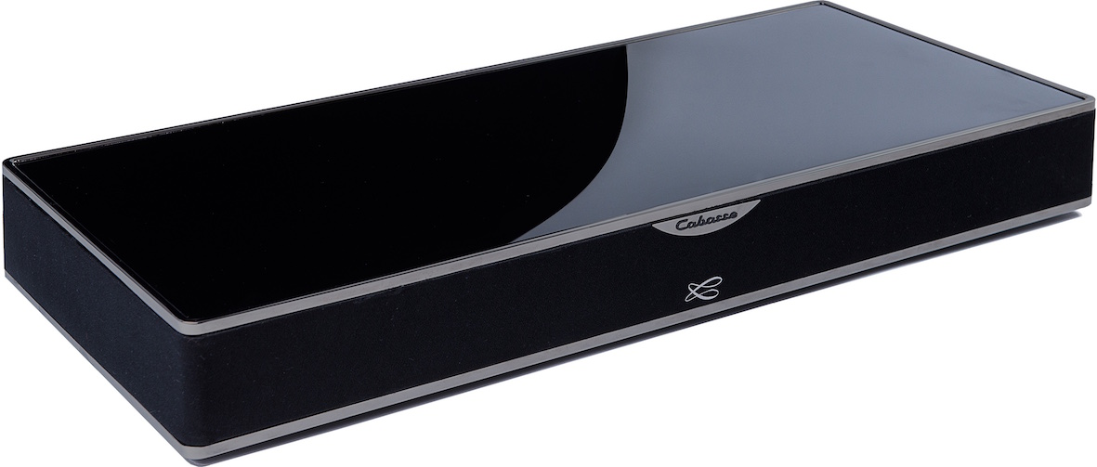
Connected Distribution, UK distributor for Cabasse, is pleased to introduce the Stream BASE, a compact unit that sits beneath the screen to provide high-fidelity TV sound reproduction and is the only sound base with built-in streaming from online services and network drives.

Audio pioneer, Cabasse, which has been at the forefront of active multi-way hi-fi and pro loudspeaker systems for 60 years, has designed a four-way per channel stereo solution for the Stream BASE. Active filtering technology ensures a spectacular sound quality by individually controlling the dome tweeter, the midrange and the low-midrange units of each channel. A dedicated low frequency channel, fitted with a long throw 13cm woofer firing downwards at 360°, brings substance and realism to the sound effects.

The full emotions of the user’s favourite films are enhanced with the Cabasse holographic sound processing, which enlarges the width and the depth of the sound stage, while dialogue remains clear and effects keep remain forceful. Every tone in the spectrum is rendered with accuracy, from high shrills to rumbling bass, for a spectacular show of sound that immerses the viewer in a rich 3D cinema experience in the comfort of the living room.

In keeping with the other models in the comprehensive Cabasse Stream range, when connected to a home network Stream BASE gives instant access to all of the music stored on the network, to thousands of internet radio stations and to audio streaming from Deezer, Qobuz, Spotify and Tidal. The USB port gives direct access to music stored on USB sticks or hard drives, plays it on the Stream BASE and shares it with any streaming device in your home network, thanks to the built in DLNA server technology. The Bluetooth Aptx function provides an easy and strong connection for smartphones and tablets.
…/

Connection to the TV is via optical or S/PDIF and is Dolby Digital compatible. The USB input and Bluetooth AptX inputs enable external digital sources to be connected and Stream BASE is also equipped with an analogue 3.5mm stereo mini-jack input. Files in a large variety of formats can be played back, including WAV, AIFF, ALAC, FLAC and MP3 and the Stream BASE can reproduce high-resolution audio up to 24bit/96kHz.

Mike Bonnette, Connected Distribution’s product director, says “The Cabasse Stream range has been critically acclaimed as offering outstanding sound quality, class-leading features and great value. And now with the addition of the Stream BASE, the range is further enhanced to offer a solution for customers who want a much better TV experience and want to benefit from all the streaming music services available in one easy to use, compact, package.” He continues, “For end-users, retailers and custom installers, there is a Stream product available to suit every situation and, most importantly, to provide a quality of experience that other brands just can’t match.”

Stream BASE is available now for a UK MSRP of £450 inc. VAT

Ends.

© Red Sheep Ltd. 1 April 2016

www.connecteddistribution.com

Media contact: Phil Hansen
+44 (0)7813 893525
phil@redsheep.co.uk

Connected Distribution contact: Mike Bonnette
+44 (0)1242 511133
mike@connecteddistribution.com

Notes to editors

About Connected Distribution
Connected Distribution is a Cheltenham based trade distributor of custom installation, home cinema and hi-fi products. Formed in 2000 as The Multi-Room Company, the business is the sole UK distributor of several highly respected brands: Russound, Cabasse, Centralite, Atlantic Technology, Pulse-Eight, Heed Audio and Parasound and sub-distributors for other leading brands, including Sanus, Leviton and Yamaha.

