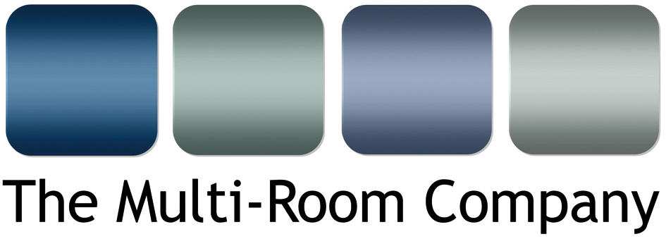

Unit 5, Eastside Industrial Estate
Mead Road, Cheltenham
Gloucestershire
GL53 7EF
T. +44 (0)1242 511133
www.multi-room.com
13 March 2015

NEWS RELEASE

The Multi-Room Company appointed as Parasound distributor

Parasound, the highly respected electronics brand, has appointed The Multi-Room Company Ltd. as exclusive UK distributor. This new arrangement, effective immediately, will provide an enhanced service offering for its existing customers and open up opportunities for additional business across the entire range of custom installation, home cinema, hi-fi and professional audio products.

San Francisco based Parasound manufactures a comprehensive range of preamplifiers, power amps, DACs, high performance multi-channel amplifiers and multi-zone amps for custom installation use. The product range is split into three sub brands, all of which will be available via The Multi-Room Company: Halo, New Classic and Z Custom, the latter of which includes the popular half width, slim line, Zdac and Zamp.

The company’s products are well regarded throughout the hi-fi and high-end home cinema sectors, receiving many glowing reviews and are much sought after by music and movie lovers across the world. A longstanding collaboration with the respected circuit designer John Curl has produced some legendary products such as the JC2BP preamplifier and JC1 mono power amplifier, both of which find favour with high-end hi-fi enthusiasts and professional recording studios. The THX certification of many of the company’s products, including the JC1, the A21, A31 and A51 two, three and five channel power amplifiers, makes them particularly suitable for critical multi-channel studio applications and as such they are specified by many of the world’s top film production companies and post production studios.

The addition of Parasound to The Multi-Room Company’s portfolio significantly improves the options for its customers, providing new solutions within custom installation and home cinema and complementing the other products it offers. Existing Parasound customers will see a determined focus on the brand and levels of personal support, from The Multi-Room Company’s technical and sales personnel, that retailers and specifiers of such products deserve.
…/

Mike Bonnette, product director for The Multi-Room Company, comments, “We are very pleased to be appointed as distributors for such a prestigious brand. The benefits presented by products of the calibre of Parasound will be extremely valuable to our customers and will open up new opportunities in the variety and scale of installations they can undertake.” He continues, “With such a comprehensive range of products we are able to service the hi-fi, home cinema, custom installation, recording studio and film post production markets, providing solutions for a huge breadth of situations. We look forward to introducing our customers to these fantastic products over the coming months.”

Ends.
No embargo
© Red Sheep Ltd. 13 March 2015

Media contact: Phil Hansen 07813 893525
phil@redsheep.co.uk

Information for Editors

The Multi-Room Company is a Cheltenham based trade distributor of custom installation and hi-fi products. Formed in 2000, the company was originally set up to primarily be a custom installation company. However; as residential technology at this time was very new to the UK, there appeared to be a gap in the middle to lower end of the market for solutions and products in the CI arena. Hence, the company evolved into a ‘one stop shop’ for the trade (AV professionals, Custom Installers and Electricians). The company is the sole UK distributors of several highly respected brands and sub-distributors for other leading electronics manufacturers, including: Atlantic Technology, Centralite, Garvan, Key Digital, Leviton, Parasound, Russound, Sanus and Yamaha.

About Parasound — Founded in 1981, Parasound Products, Inc., is a privately owned U.S. company that specialises in providing affordable audio components to the critical listener. The company's ever-improving line of audio products has garnered a reputation for performance, value, and reliability. The highest quality standards are assured by Parasound's relationships with their Taiwan audio manufacturers that date back to 1982.

