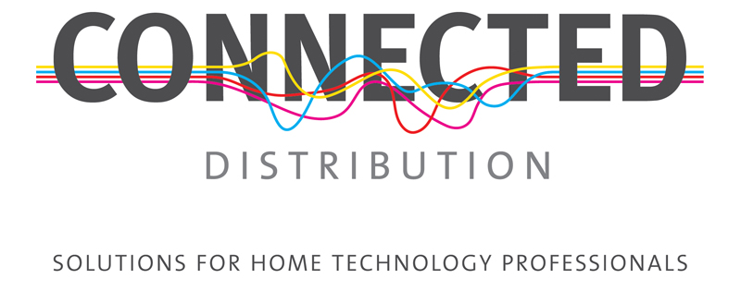
Unit 5, Eastside Industrial Estate
Mead Road, Cheltenham
Gloucestershire
GL53 7DT
T. +44 (0)1242 511133
www.connecteddistribution.com
14 November 2016

PRESS RELEASE
For immediate attention

70V Line Streaming Mixer Amplifier from Russound

Connected Distribution, the Russound UK distributor, is introducing the XZone70V Streaming Audio Amplifier to give installers a powerful product for building business in the light commercial sector.

The first Russound 70v model to be launched, the XZone70V Streaming Audio Amplifier is a high resolution digital media streaming source that enables very long run and multiple speaker installations for commercial environments. Incorporating the company’s XStream technology, the XZone70V provides streaming audio content from the cloud via vTuner, TuneIn and Spotify, from a local network and Apple AirPlay™ devices. Its powerful 70v/100v amplifier provides up to 300 watts of power in a single 1U chassis, making it the perfect solution for commercial installations.

Additional sources can be connected via a rear mounted USB socket for use with a flash drive or external hard drive, and a 3.5mm input jack gives the flexibility to add any other local source to the system.

Essential for commercial installations is the integrated microphone input that automatically senses a signal and pauses the audio stream for paging through the system. Condenser microphone support is easily accessed with a sliding switch on the rear panel, in addition to a mic gain control for easy adjustment of the audio level, and a front panel mic volume level that gives users access to increase speech volume as the environment dictates.

Overcoming the known limitations of 70v line systems, namely the potential for saturation of even the best speaker transformers, and hence distortion, when running low frequencies through them, the XZone70 incorporates a dedicated high pass filter to block these signals. When used in the optional 4-ohm mode, with traditional loudspeakers, the high pass filter is switched out of the circuit to permit the full frequency range to reach the speakers.
…/

Russound has also produced a number of dedicated 70v accessories for use with the XZone70V, including the all-weather AW70V6 speakers and a 50W 70V volume control, which can be used at each speaker location for individual adjustment of level.

“XStream models for the home are proving to be a big hit with installers who want a simple, highly efficient audio streaming solution for projects of any size,” said Mike Bonnette, product director for Connected Distribution. “With the introduction of the 70v version, installers who operate in, or want to get into, light commercial installations can now take advantage of Russound’s powerful streaming technology.”

Ends.

© Red Sheep Ltd. 14 November 2016

www.connecteddistribution.com

Media contact: Phil Hansen
+44 (0)7813 893525
phil@redsheep.co.uk

Connected Distribution contact: Mike Bonnette
+44 (0)1242 511133
mike@connecteddistribution.com

Notes to editors

About Connected Distribution
Connected Distribution is a Cheltenham based trade distributor of custom installation, home cinema and hi-fi products. Formed in 2000 as The Multi-Room Company, the business is the sole UK distributor of several highly respected brands: Russound, Cabasse, Centralite, Atlantic Technology, Pulse-Eight, Heed Audio and Parasound and sub-distributors for other leading brands, including Sanus, Leviton and Yamaha.

