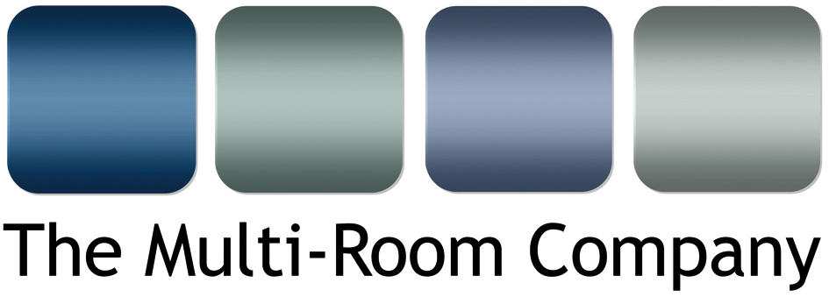

Unit 5, Eastside Industrial Estate
Mead Road, Cheltenham
Gloucestershire
GL53 7EF
T. +44 (0)1242 511133
www.multi-room.com
28 July 2015

NEWS RELEASE

ZEF: THE NEW OUTDOOR CUSTOM INSTALL SPEAKER FROM CABASSE

Available exclusively in the UK from The Multi-Room Company, Cabasse is launching the ZEF 13/13tr and the ZEF 17/17tr speakers. Designed by the sea at the Cabasse Acoustic Center, the ZEF range is the ideal solution for high quality sound reproduction in outdoor conditions or more sedate indoor surroundings.

The famous reliability of the technical solutions developed by the Cabasse Research and Development department is a guarantee for longevity. The quality of the components involved offers a maximum sound pressure and a low frequency extension not normally expected from such a tiny volume, with a respect of timbres and a sound stage most hi-fi loudspeakers would be proud to claim.

The 2-way ZEF 13 and ZEF 17 contain almost identical features, with Cabasse's DOM25 tweeter and their 13T15AW midrange woofer in the ZEF 13, although the ZEF with the 17T15AW midrange woofer has the capability to produce a wider frequency range. Both give exceptionally true performance due to these superior parts and design, typical of Cabasse but unusual for this more 'ultilitarian' type of speaker.

This product is designed to be used inside or outside, providing the same high quality sound in either placement. The ZEF speakers are available in black or white and the come with a wall-mounting bracket. Additionally, for more flexible placement there is a dedicated 'ball bracket' available.

The TR version is the more commercialised speaker in the range, and is fitted with a transformer and a power switch for 100V or 70V high impedance mode. This allows the speaker to work over long distances while retaining the same high performance and sound quality.

Ends. No embargo

© Red Sheep Ltd. 28 July 2015

www.multi-room.com
www.cabasse.com

Media contact: Phil Hansen +44 (0)7813 893525
phil@redsheep.co.uk

Notes to editors

About Cabasse
Founded in 1950 by Georges Cabasse, the Cabasse firm inherited not only its creator’s name, but also his genius. Georges Cabasse is from the world of music, and he is gifted with a special talent. He has a unique memory for sounds. Probably a gift from his ancestors, hailing back to a stringed instrument maker who crafted the first violin signed Cabasse in 1740 at Mirecourt in the Vosges Mountains. Five generations of craftsmen followed him, pursuing the tradition and supplying Europe with violins, violas and cellos, most of which are still being played in orchestras today. The fact remains that Georges Cabasse’s obsession is to perfectly reproduce the concerts he loves, without any alteration, coloration or distortion in the sound. This boundless passion has led him to relentlessly innovate, transmit and share his exacting requirements with the rest of the Cabasse team, so that all ears can enjoy the essence and thrill of pure sound. Today, the Cabasse range presents one of the most complete portfolios of loudspeaker products for the hi-fi, home cinema and custom installation markets, from discrete in-ceiling speakers through to the range topping and class leading L’Ocean and La Sphère audiophile speakers.

About The Multi-Room Company
The Multi-Room Company is a Cheltenham based trade distributor of custom installation and hi-fi products. Formed in 2000, the company was originally set up to primarily be a custom installation company. However; as residential technology at this time was very new to the UK, there appeared to be a gap in the middle to lower end of the market for solutions and products in the CI arena. Hence, the company evolved into a ‘one stop shop’ for the trade (AV professionals, Custom Installers and Electricians). The company is the sole UK distributors of several highly respected brands and sub-distributors for other leading electronics manufacturers, including: Russound, Leviton, Cabasse, Centralite, Key Digital, Atlantic Technology, Parasound and Yamaha.

