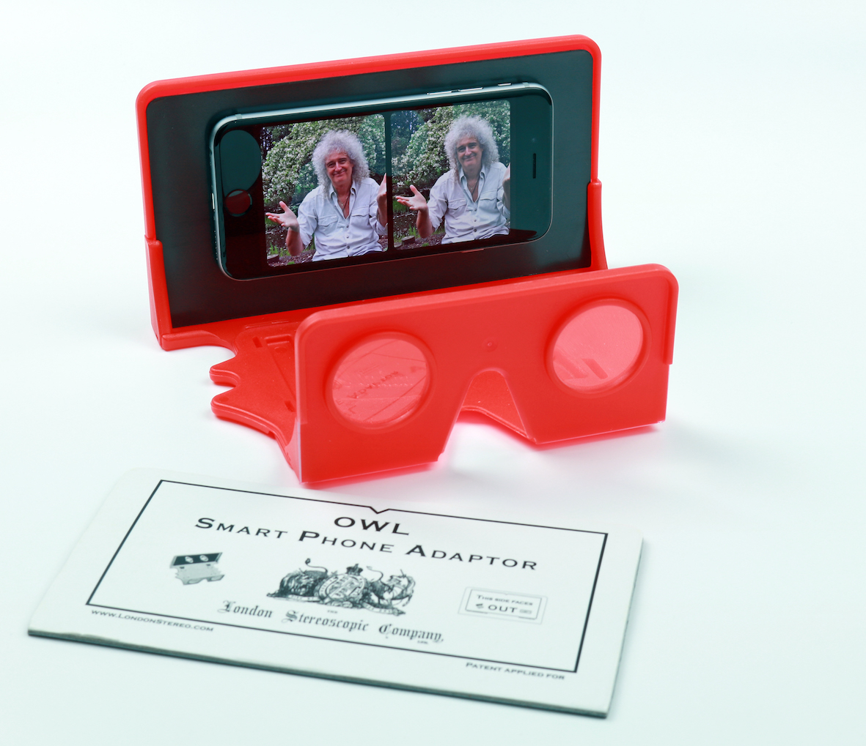
London Stereopscopic Company Ltd
The River Wing
Latimer Park
Latimer Road
Chesham
Bucks HP5 1TU

24 May 2016

PRESS RELEASE
For immediate attention

Virtual Reality from Brian May. It’s real.

Lifelong stereoscopy enthusiast and collector, and, incidentally, world-famous rock guitarist, Brian May this month launches the OWL VR Smartphone Kit, a Virtual Reality and 3-D stereo image viewer that brings all the excitement of VR within reach of anyone with a smartphone.

Brian’s London Stereoscopic Company (website LondonStereo.com) has been supplying his unique original patent OWL Stereo Viewer to 3-D enthusiasts since 2009, enabling a whole new audience to view the company’s reproductions of classic Victorian stereo cards, as well as the originals, plus recently released astronomy and Queen-focused 3-D images. The OWL has been recognised and adopted by 3-D organisations world-wide, as a high quality immersive device.

The new OWL VR Smartphone Kit takes the existing OWL Stereo Viewer and, through use of a simple but ingenious adaptor, enables its use with a smartphone not only to view online 3-D images, but also those taken by the user, and commercially available virtual reality content. Manufactured from high-grade polypropylene, and fully collapsible to a thin flat configuration, the OWL is supplied ready for use in seconds. Its carefully positioned high-quality optical lenses, plus fully adjustable focus, present every user with the ideal optical geometry for perfect viewing of side-by-side 3-D images.

Working with any smartphone, the OWL VR Kit has a significant advantage over most other VR devices, which are usually tied to jut one particular make or model of phone. And, in contrast with most of the low cost viewers available, the OWL kit offers full access to the controls on the phone at all times. Access to the headphone socket is also unobstructed. This is particularly useful when using the OWL to watch virtual reality films of concerts, or other content with a soundtrack. It also enables users to connect their smartphone to a home cinema system to generate surround sound to complement the 360° 3-D visuals.

Commenting on the launch, Brian May said, “Virtual Reality has taken the consumer electronics world by storm over recent months and masses of content is now rapidly becoming available. However, until now, users have had the choice of an expensive VR viewer that puts it out of reach of many people or a very low cost alternative that just doesn’t do the format justice.” He continues, “The OWL Smartphone Kit changes all that; for a very modest outlay, anyone can now enjoy the VR experience, and also gain access to the fascinating world of Stereoscopy. Plus, with the apps that are available for smartphones, it’s now possible to take your own 3-D images and enjoy them instantly using this simple OWL Kit.”

…/
The OWL Smartphone VR Kit will be available from June 2016 for £25, direct from www.londonstereo.com/lsc_shop.html

Ends. No embargo
© Red Sheep Ltd. 24 May 2016
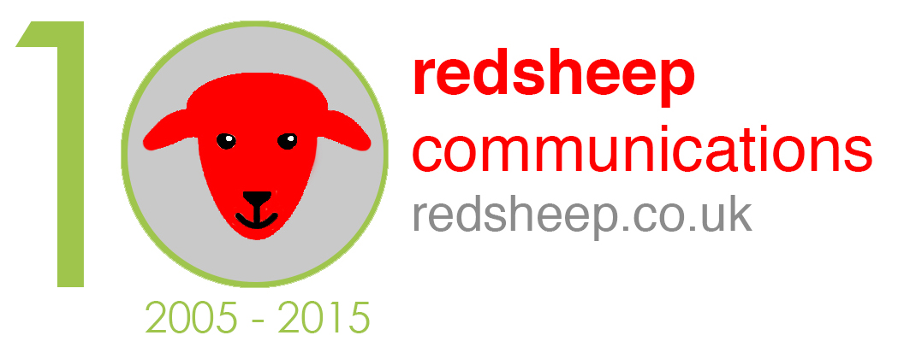

Media contact: Phil Hansen
+44 (0)7813 893525
phil@redsheep.co.uk

Notes for Editors.
About the London Stereoscopic Company

Some time in 1854, at 313 Oxford Street, the “London Stereoscope Company” was born and, under the leadership of managing partner George Swan Nottage, by 1856 the company had changed its name, to “The London Stereoscopic Company”, and finally in May 1859 assumed the name it was to retain for years to come: the “London Stereoscopic and Photographic Company”. Its business was selling stereo views and viewers to the public, and they were leaders in a boom – a craze which swept England, Europe, and eventually the United States too.

In 2008 Brian May and a likeminded group of enthusiasts, re-founded The London Stereoscopic Company with the stated objective of recreating the magic of the company and bringing the experience of 3-D photography and latterly virtual reality to a whole new generation.

