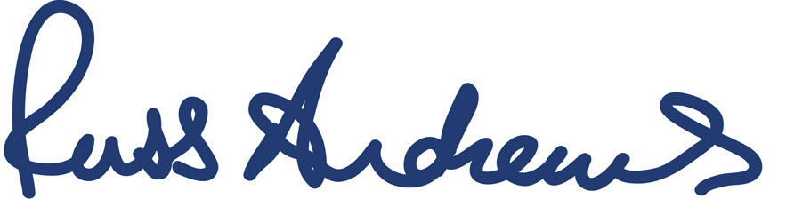

Russ Andrews Accessories Ltd.
2B Moreland Court
Westmorland Business Park
Shap Road
Kendal
LA9 6NS

12 October 2018

PRESS RELEASE

Personalised balanced mains from Russ Andrews – the BMU1500 mkII

Russ Andrews Accessories is introducing the latest version of its BMU1500 Balanced Mains Unit to provide a colossal 1.5kVA of clean power, individually tailored to each installation, to provide superior music and movie reproduction.

Working on the same principle as balanced audio signals - where the audio signal is split into two halves; negative and positive - the BMU1500 mkII splits the 230v mains signal into two separate 115v supplies. One is carried on the live and the other on the neutral and as each is a different polarity (negative or positive) the noise on one is cancelled out by the noise on the other. The result is a 230v power supply that is free from noise and hence provides the connected equipment with a cleaner supply.

Where the new BMU1500 mkII differs most from its predecessor, is in the personalised nature of its set up. The electricity supply in the UK by law has to be 230V +10% -6%, giving a minimum of 216.2V and a maximum of 253V, which means the balanced mains unit will not always be working at its optimum efficiency if set to 230v and the user's domestic voltage differs from this. Prior to installation of a customer’s BMU1500, Russ Andrews will supply a simple to use, plug in, mains voltage checker. The customer will be asked to measure their house mains voltage over a period of seven days, particularly at the times of day they are most likely to use their hi-fi system, and then supply Russ Andrews with the readings. Before shipping the BMU to the customer, the unit will be factory set to the average of the seven days readings. This ensures the BMU will work as efficiently as is possible to provide the maximum audible benefit. …/

The unit is equipped with a newly-designed balanced mains transformer, which is quieter in operation than conventional transformers, to provide the total 1.5kVA of power. Five Russ Andrews UltraSocket mains outlets on the rear enable connection of the hi-fi or home cinema equipment directly to the unit – thereby acting as a mains extension as well as the balanced mains supply. Mains input is via a 16A IEC socket and is protected by use of a high quality two-pole (live and neutral) circuit breaker and the unit is encased in a bespoke ABS case with black anodized front panel.

Russ Andrews, technical director and chairman of the company, says, “Balanced audio signals have long been acknowledged to provide a superior sound quality thanks to the noise cancelling characteristics of the design. It is for good reason that such systems are used extensively in professional recording studios.” He continues, “By adding a balanced mains unit to a home set up, the performance benefits long understood by the professionals can be enjoyed at home. And, with our individual tailoring to the supply voltage in the customer’s house, they can be assured of the very best performance to allow their music to really shine.”

Ends. No embargo
© Red Sheep Ltd. 12 October 2018

Images from
https://www.dropbox.com/sh/8z38moycuqsg4bp/AACd8ar1FZdfnZA8-HAfBd_aa?dl=0

Prices
BMU1500 Balanced Mains Unit £2550

Media contact: Phil Hansen
07813 893525
phil@redsheep.co.uk

Russ Andrews contact John Armer
01539 797300
john.armer@russandrews.com

www.russandrews.com
Tel. 01539 797300

Notes to editors
Russ Andrews is a hi-fi and home cinema company, founded in 1986.
Based in Cumbria, UK, the company designs, manufactures and sells its products from its Kendal headquarters, employing 12 people. The product range includes Hi-Fi and Home Cinema mains cables, interconnects, speaker cables, supports, accessories and Hi-Fi equipment. As well as manufacturing its own Russ Andrews brand products, the company is the sole UK distributor for the well-regarded US specialist cable company - KIMBER KABLE. It also sells; selected Meridian products; the Rupert Neve Designs RNHP headphone amp, the Cabasse Stream range; Ringmat products; Audio Desk record cleaning machines, DeoxIT products and WBT connectors.
Russ Andrews’ product range has been built up since 1986, with many products designed by chairman and technical director Russ Andrews, who has over 40 years experience in the hi-fi industry. Russ originally started out as a hi-fi dealer, becoming a Research and Development consultant for several major British manufacturers, before setting up his own company.

